**Conceptual Diagram (Project X)**

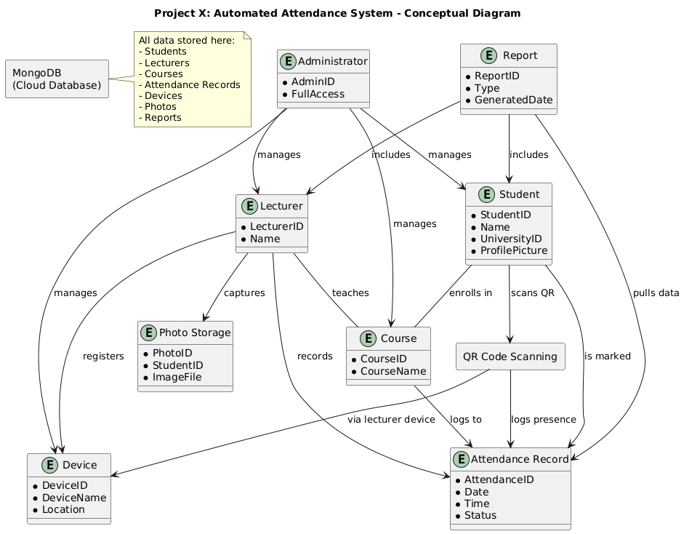

### User Roles and Entities

**Student**

* Each student has a unique ID, name, university ID, and a profile picture.
* Students can **enroll in courses** and **record attendance** by scanning QR codes.

**Lecturer**

* Responsible for managing attendance and capturing student photos.
* Lecturers can **register multiple devices**, **log student attendance**, and are tied to specific courses.

**Administrator**

* Has full access to **create, read, update, and delete** records for students, lecturers, devices, and courses.
* Manages the overall system structure and user data integrity.

**Course**

* Central entity linking students and lecturers.
* Attendance is tracked per course, identifying which student was present at a specific time.

**Attendance Record**

* Captures the **date, time, and status** (e.g., present or absent) of a student’s attendance.
* Linked to a course, lecturer, and student.

**Device**

* Each lecturer can register devices (e.g., mobile phones, tablets).
* Only registered devices are authorized to capture attendance, ensuring security and accountability.
* Devices are also used for QR code scanning.

**Photo Storage**

* Stores **passport-style student photos** captured by lecturers.
* Photos are securely stored and linked to student IDs for verification purposes.

**Report**

* The system can generate reports filtered by **student**, **course**, or **date range**.
* Reports are accessible to lecturers and administrators for decision-making and record-keeping.

### QR Code Scanning Process

A key component of attendance logging is the **QR Code Scanning** mechanism:

* A student scans a dynamically generated QR code using a **registered lecturer device**.
* The system links this interaction to the student, course, and timestamp.
* The attendance record is **instantly updated in the system**.

This approach ensures **contactless, fast, and accurate** attendance capture.

### Cloud Storage – MongoDB

All data from the system is securely stored in **MongoDB**, a cloud-based NoSQL database:

* Stores structured data like students, lecturers, courses, attendance records, devices, and photo references.
* Ensures real-time access and data persistence.
* Facilitates reporting and API access for mobile/web clients via RESTful endpoints.

### Interactions Overview

* **Students ↔ Courses**: Students enroll in one or more courses.
* **Lecturers ↔ Courses**: Each course is assigned to a lecturer.
* **Lecturers ↔ Devices**: Lecturers register devices used for attendance capture.
* **Students ↔ QR Code Scanner**: Used to log attendance.
* **Administrators ↔ All Entities**: Admins manage and oversee the entire data ecosystem.
* **Reports ↔ Attendance, Student, Lecturer**: Reports are dynamically generated based on real-time data.

**Security and Role Control**

The system enforces strict **role-based access control**:

* Only authorized roles can access or modify specific data.
* Attendance can only be recorded using **verified devices**.
* Photo and student information are **securely stored** and only accessible to designated roles.